**HISTORY**

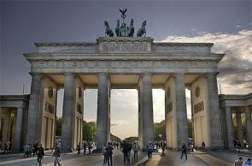

The GCSE History revised qualification for September 2017 will offer learners the opportunity to study significant events and people in the past to enhance their understanding of the world today. There will be opportunities to explore key political, economic and social events that have helped shape today’s institutions, governments and societies.

Students will be encouraged to explore how the past has been represented and interpreted and for different reasons and purposes. They examine the attitudes, perceptions and ideologies that have influenced behaviour, how people in the past have interacted with their environments and how this has contributed to historical events. A strategically planned trip to Berlin enhances the curriculum for the students who chose to go on the trip at the end of Year 11 studies.

In terms of skills, pupils will be encouraged to develop effective communication of historical knowledge and understanding in a range of ways. They will be shown how to argue a case, make judgements and reach substantiated conclusions.

Candidates will complete three areas of study over two years assessed in two examination papers.

|  |
| --- |
| **Unit 1 Section A: Modern World Studies in Depth - Life in Nazi Germany, 1933–45 (30%)** |

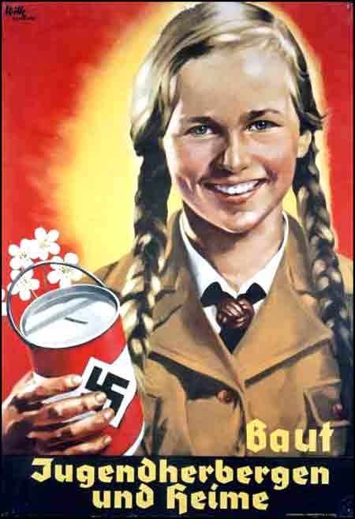In this option, students focus on the impact of the Nazi dictatorship on people’s lives in Germany. Students explore the dramatic interplay of political, economic, social and racial forces in Germany at this time. Areas covered include:

* ***Hitler takes political control, 1933–34***

## Control and opposition

## Life for workers in Nazi Germany

## Life for women and the family in Nazi Germany

## Life for young people in Nazi Germany

## Life for the Jewish community and minorities in Nazi Germany

## Germany at war

**Unit 1 Section B: Local Study - Northern Ireland and its Neighbours, 1920–49 (30%)**

In this option, students focus on the changing relationships between the north and south of Ireland and Britain following the partition of the island of Ireland. Students examine the changing relationships against the backdrop of peace, war and neutrality. They also explore the significant impact of World War II on relations between Northern Ireland and its neighbours.

Areas covered include:

* 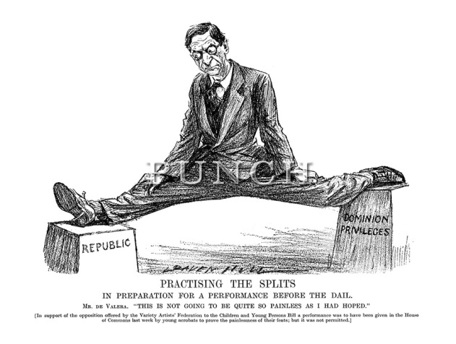***The partitioning of Ireland***
* ***From Irish Free State to Éire***
* ***The Economic War***
* ***Northern Ireland and World War II***
* ***Éire's neutrality and its impact on relationships during the war***
* ***German attacks and their impact on Britain, Northern Ireland and Éire***
* ***Life in post-war Northern Ireland and Éire, 1945–49***
* ***Constitutional changes and effects on relationships***

****Unit 2: Outline Study – International Relations, 1945–2003 (40%)**

In Year 12 students focus on the significant events and developments associated with the Cold War and the new ‘war on terror’. Students learn about how and why conflict occurred, attempts at resolving tensions and how international relations have been affected by the Cold War and the ‘war on terror’. Areas covered include:

***Co-operation ends and the Cold War begins***

• Breakdown of the wartime alliance between the USA and USSR in 1945:

***Emerging superpower rivalry and its consequences,1945–49***

• The Soviet takeover of Eastern Europe

***Flashpoints in Europe and the impact on international relations***

• The actions of the USSR in Eastern Europe and the impact on international relations:

***Flashpoints outside Europe and the impact on international relations***

• The actions of the USA and USSR outside Europe and the impact on international relations including:

* 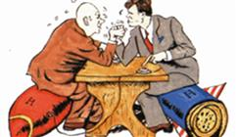The Korean War, 1950–53
* Conflict in Vietnam,
* The role of China
* The Cuban Missile Crisis, 1959–62
* The Soviet war in Afghanistan, 1979–89

***The end of the Cold War, 1985–91***

• The actions of the USSR and USA in Europe and the impact on international relations:

* The policies of Gorbachev and the role of President Reagan
* The collapse of communism in Eastern Europe and the ‘end’ of the Cold War

***New tensions emerge, 1991–2003***

• The new age of conflict, the ‘war on terror’ and the impact on international relations:

* The rise of the Taliban and the origins of Al-Qaeda
* Reasons for the invasion of Iraq, 2003, the downfall of Saddam Hussein and the impact of the Iraq War on international relations

In GCSE History, candidates are encouraged to develop their quality of written communication. They are challenged to analyse critically and assess evidence to understand how information or evidence can be manipulated. This specification prepares students for a range of careers, related to both the historical context and a wider employment context. Our departmental staff utilise strategies to continually review and monitor progress and pursue ways of learning to improve pupil performance. We build on strengths and identify when support is needed. Ultimately, students are invited to form their own views on key historical issues, justified with substantiated knowledge thereby promoting skills that are transferable and highly valued by employers.

**PAPER ONE**: External written examination over 1 hour 45 minutes

There are two sections and the paper includes short response questions, source-based questions, structured questions and an essay question.

**PAPER TWO**: External written examination over 1 hour 15 minutes

The paper includes source-based questions, a structured question and an essay question.

|  |
| --- |
| **Who can I get more information from?** |

<https://successatschool.org/advicedetails/210/Why-Study-History%3F>

<http://www.ccea.org.uk/history/>

<http://www.thecompleteuniversityguide.co.uk/courses/history/7-reasons-to-study-history/>

<http://www.bbc.co.uk/schools/gcsebitesize/history/mwh/>

<http://strathearn.org.uk/studying/history.php>

Strathearn History Department Staff